Have you started to secretly hate your business?
Are you scrambling to attend so many parties in your network marketing business?
You wonder where the "home" in “home-based business" went?
Are you just getting more and more worn out - and you're still not getting ahead?
Of course, when asked, you smile and tell everyone how much you love being an entrepreneur and that your business is growing and great.
And eventually it will be, and it will all get easier, you think. Or at least that’s what you keep telling yourself.
But each and every day you’re getting more and more tired, frazzled, and just plain worn out with everything that’s on your plate.
And lately it almost seems like you don’t own your business – it’s owning and running you!
Maybe you’ve even tried to get ahead by investing in some training or coaching only to be oversold and under delivered.
…ask me how I learned about that sleazy tactic.
You need one hour a day.
This document is a complete treasure map that will guide you through what it takes to create a profitable business you have been working relentlessly towards.
Really!

What it does take is having laser-like vision to be able to see what’s working and what isn’t and then make focused adjustments(or little tweaks, as I like to call ‘em) where needed, and then commit to action.
Making the shift to the point where I experienced massive success without having to sacrifice every waking moment of time came from tweaking my marketing plan, adjusting positioning strategies, and repackaging my expertise.
These tiny adjustments were what it took to experience growth, as in the 6-figure kind of growth! Yep! Using social media and my blog with one laser focused hour a day.
Does that sound like the growth you're looking for? I will be telling you how I built my business and the tools I used.
In my book MLM Blueprint: Secrets to Building Your Network Marketing Empire I go into more details. Hop over to Amazon and get your copy.
Building Real Relationships with your Followers
What’s your first thought when you imagine the process of going to a car dealership and buying a car?
If you’re like most people, you automatically picture a pushy salesperson who will say anything to get you into a car!
It’s not an experience that people typically like, is it?
But what is it about this experience that people hate? I mean, after all, people usually like other kinds of shopping. And for something like a new car, it should be fun, right?
I think it comes down to one thing – people like shopping but they don’t like feeling like they’re being sold.
People love to shop!
There’s a stereotype about car salespeople, the sleazy sales guy who comes up to you and says, “What would it take to get you in this car today?”
Yep…I’ve heard that line…from someone who wanted to get me in a car that reeked of old odors – there was no way I was going to buy that car that day!
What put me off was that he didn’t take the time to get to know me, my needs, my wants, and certainly the fact that even if he were paying me, I wouldn’t be driving that car home!!!
What does this have to do with growing your business fast using social media?
Everything.
If your connections on social media see you as selling without building relationships, they’ll like you about as much as you like those car salespeople.
You might have heard people saying that you need to build relationships on social media. And some people can likely figure out how to do that…it’s pretty much like building relationships in real life.
Especially when you’re new to growing your business, or you are feeling desperate about making ends meet, it’s easy to think that you won’t sell enough if you aren’t mentioning your products or services on social media every single time you post.
But strangely enough – people can sense your desperation through the screen, and if every post has even a “cleverly disguised” reference to buying your stuff, you’ll drive your prospective customers away faster than you ever thought possible.
So how do you build relationships on social media?
When someone reaches out to become "friends" on Facebook, take the time to look at their profile. See what you have in common and send them a private message.
Say hello.
Mention something you saw on their profile to let them know you were interested in learning more about them.
Ask some questions to see if you can get a conversation starter.
This is NOT the time to sell them something. You are just building the friendship or see if there is an opening for more information.
How long have you been working in the profession?
Have you ever considered doing anything else?
Would you consider yourself a self-starter and driven, or are you pretty happy with where you are?
I don’t know if this is a fit for you, but I thought I’d throw it out there given how motivated you seem.
Not every connection is a business relationship, but every connection can be a new friendship. Friends are great for referrals.
Below is a conversation starter I used that got 863 LIKES and 826 shares in one day!
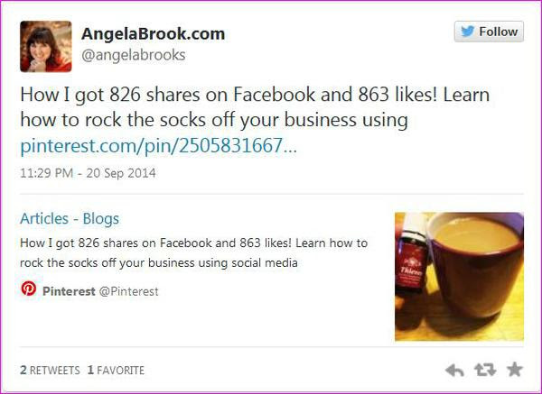

Picture this – you and your family have just sat down to dinner. Everyone is ready to dig in – and the phone rings.
You answer because clearly, no one would dream of calling at the dinner hour unless it was really important. But the voice on the other end of the line is an automated computer, calling to pitch a product, service, or candidate.
You mumble under your breath and hang up the phone.
If you’re anything like me, that’s one of the biggest ways for me to not buy your product or service.
When people find out more about you and they begin to know, like and trust you. They are more likely to share your products with someone they may know.
Learn who they are.
Become interested in people.
When it’s time to actually interact with people, you absolutely must not automate or sound like a commercial.
The same is true online.
​​​​​​​Here is a sample script I use on Facebook (change it to fit you and your words) when I find there are people I have not talked with. (It happens with 10,000 people on my page.)
Hey there, I just have to apologize. I know you have been on my friend's list for quite some time and I’ve seen your status updates pop up. I’ve never taken the time to reach out to you. I hate that Facebook can be so impersonal sometimes. Anyways, just wanted to connect, noticed you’re in [ business ], is that something you enjoy?
Angela Brooks
Note: If the person is someone I’ve talked to or met, I will send them a simple message to get a conversation started.

The biggest thing that people leave out of social media is being social. Then they get frustrated because no one is responding when they plaster their products all over their wall.
When you take a few minutes a day to join in on some conversations, like a few comments or share some posts, people will start doing the same for you. It really is that simple.
When you meet someone at a party, what are usually the first areas of conversation?
Usually, you talk about your jobs, or maybe you comment on current events in sports or something that the other is wearing, or a great serving piece that looks like one you just saw in the new Pottery Barn catalog, or whatever.
You get the point –
When you get to know someone, there’s a lot of discovery involved.
You find out about each other.
The same thing is true in social media marketing.
There’s a period of getting to know one another. And the thought of trying to market to someone without taking the time to know them is just awful, in my book.
It’s like being at that same party and meeting someone – except all they want to do is talk about themselves and how great they are.
You’ve met “that person” at least once, I’m sure.
But do you want to be that person?
I’m guessing you just answered with a loud no. (If you didn’t, I still sure hope you don’t want to be that person!) When you connect with someone on social media and immediately bombard them with a link to your hot sale or new product or whatever, that’s exactly what you’re doing!
I call this puking on people.
​Watch and Listen - people will tell you what they need. It is your job to figure out how your product or service can fix their problem. Then you are not just selling you are serving a person's needs.
The #1 thing most people are concerned about is not how awesome your company is but how you can help them with a problem. You get their attention when it directly affects them.
Become a problem solver and people will start listening.
Even if you have zero interest in recruiting on social media to build your business, I still highly recommend you using the tips I gave you over the last few days. You will begin attracting people to you instead of pushing them away.
I hope you have gained some value out of this guide. If you are ready to invest in your education, hop over to the crash course to make people fall madly in love with your products.
Learn how to use a blog and social media to create a community who loves you and what you do.
Before you go… if you want to have more education training - This is the Attraction Marketing System I recommend:
http://angelabrooks.weeklymarketingwebinars.org
Angela Brooks
www.AngelaBrook.com

